**KAMALI KINUTHIA**

**C025-01-0639/2020**

**Thirst for Change: A Photographic Journey into the Struggle for Clean Water**

**Introduction**

**Opening Statement:** Access to clean water is a fundamental human right, yet millions in African communities still struggle to obtain it. This photographic essay explores the challenges faced by these communities and the efforts being made to secure clean water for all.

**Context:** In rural areas of Northern Kenya, water scarcity is a daily struggle. Families often get forced to travel long distances to collect water, which is frequently contaminated. This essay focuses on the lives of those affected and the initiatives striving to bring change.

**Visual section**

**Problem Statement**

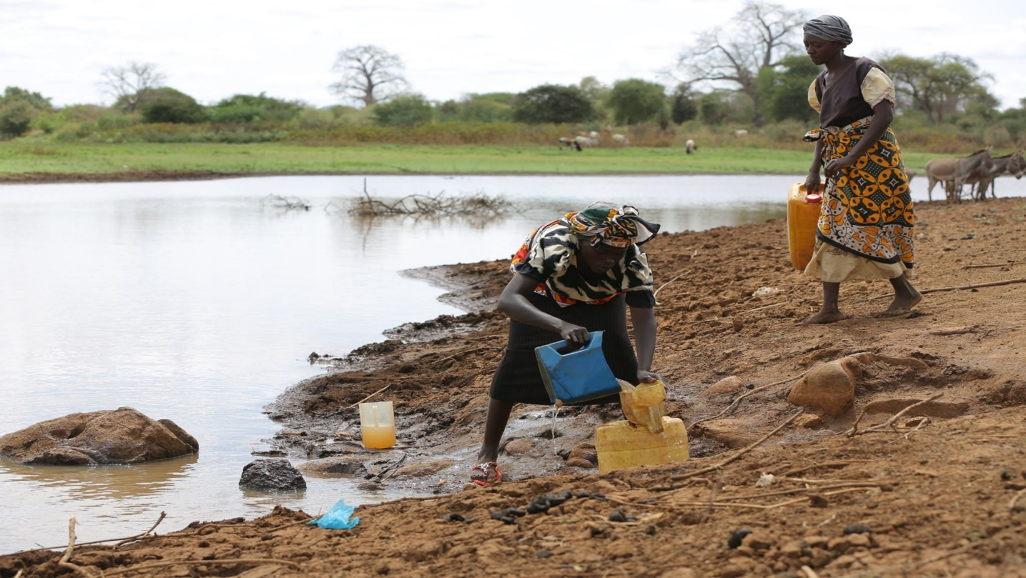

This image depicts women drawing water from river. Residents often rely on such water sources for daily water use which are a great risk due to exposure of water borne disease.

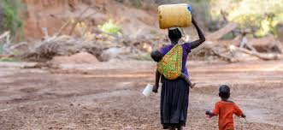

This image shows a woman with a jerrycan on her head whilst carrying a kid on her back. Women and children in such communities are often forced to walk greater distances to fetch water for their daily use. Sometimes the distance could clock an estimate of ten kilo meters on foot.

**Daily life and impact.**

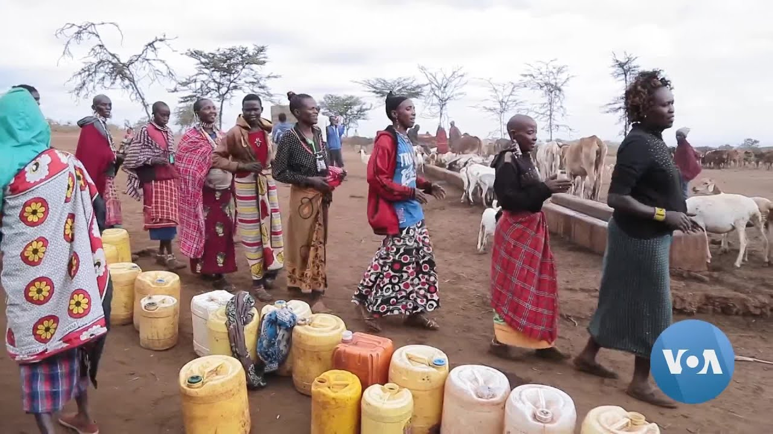

This image shows a typical daily life of people in those communities. Apart from walking long distances to water sources, they are required to sit in line for hours to get the water and another distance back home. This consumes a lot of time leaving very little time for the involved to indulge in other activities.



This image shows a kid drawing water from a well. This water often untreated poses a great risk to contract water borne diseases. According to sources, people in such communities have a high rate of water borne disease infections such as bilharzia, cholera.

**Community efforts.**

In response to these problems, communities and NGOs are coming together to find a solution.



A group showcasing their water filtration system. The system comprising of two buckets stacked on top of each other, works by allowing water to filtrate through the top bucket down to the bottom bucket, where it is safe and clean.

**Positive Outcomes and Solutions.**

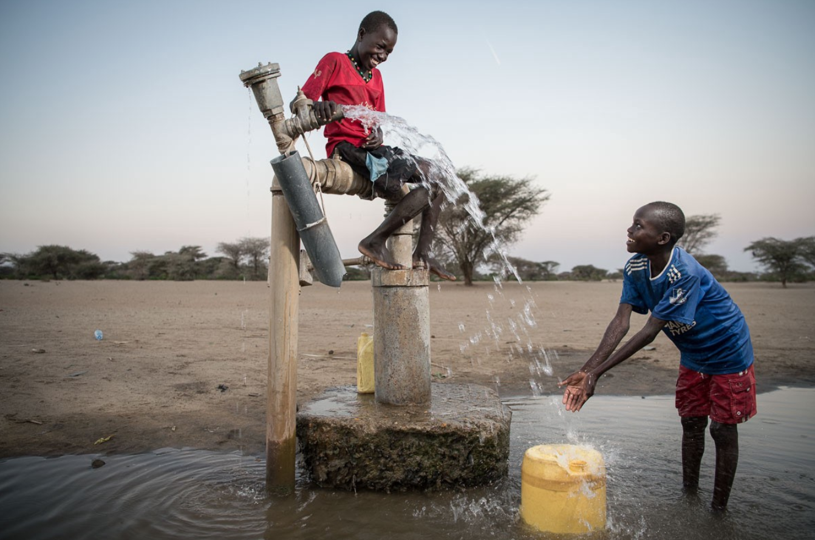

Children enjoying water from a drilled borehole. Drilled borehole are more reliable and give much more safer water compared to open water sources.

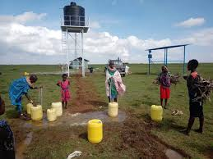

Women enjoying water from a tap supplied from a tank. This kind of water source often from a borehole uses solar power to pump to a high tower water tank, which supplies piped water though gravitational force. This is a clean and sustainable solution.

**Conclusion**

**Summary:**

The struggle for clean water reflects a broader global challenge, where millions face similar hardships. This photographic essay has captured the daily realities of those living without reliable access to clean water and highlighted the resilience of communities striving for change. Through the lens of these images, we see not just the difficulties but also the transformative power of clean water. Improved water access leads to better health outcomes, empowers communities, and creates opportunities for growth and development.